Instructions for Final Submission
Step1：Login to your account to access to the submission website.
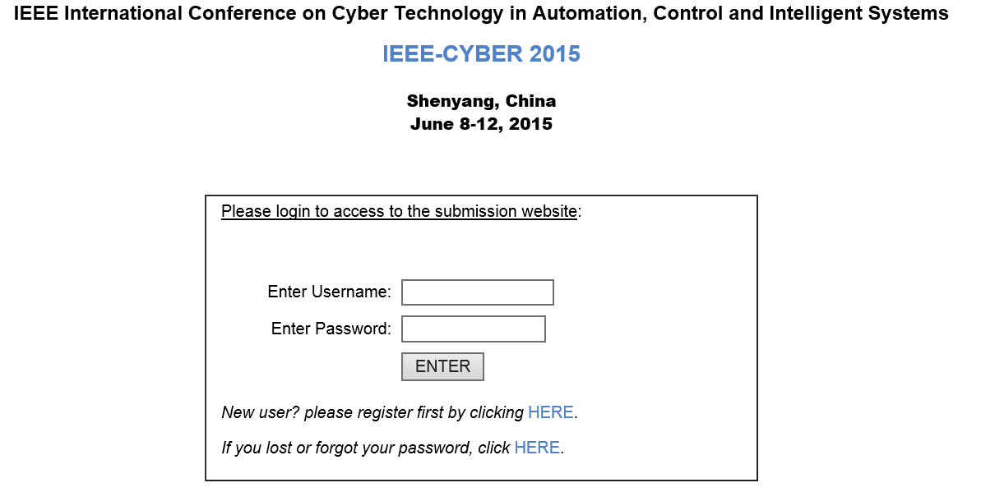
Step2: Select the option “Your current Submission(s)” to access to your submissions.
Step3: Enter the submission passcode which has been sent to your email when you successfully submitted your paper.
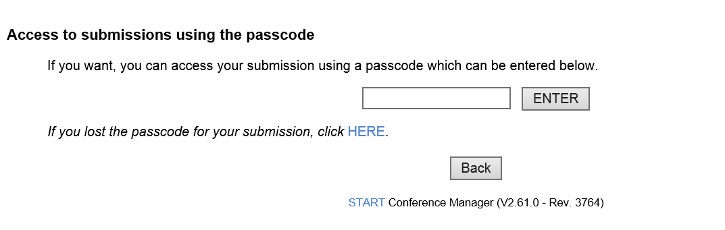
Step4：Select the option “Final camera-ready submission: Submit your Final camera-ready submission” to access to the Final Submission Page.
Step5: First click the option “Please Click here to submit IEEE Copyright information” when you have confirm your title of submissions and list of authors.
Step6: Follow the instructions on the screen and finally click download to obtain your PDF copyright receipt.
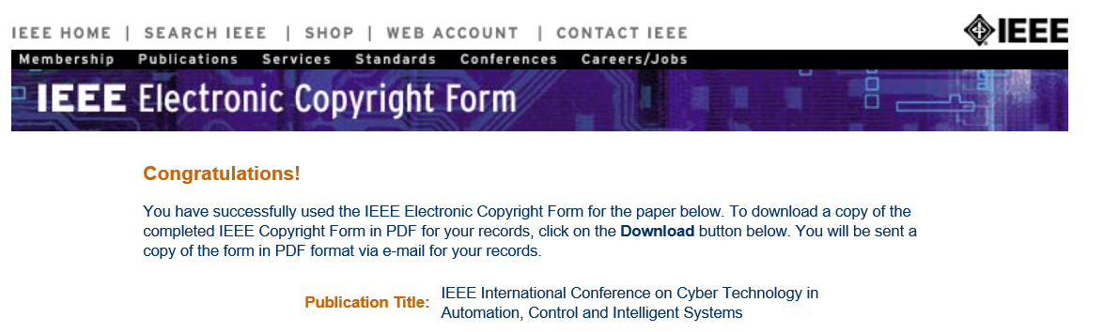
Step7: Upload the PDF copyright receipt obtained in Step6.
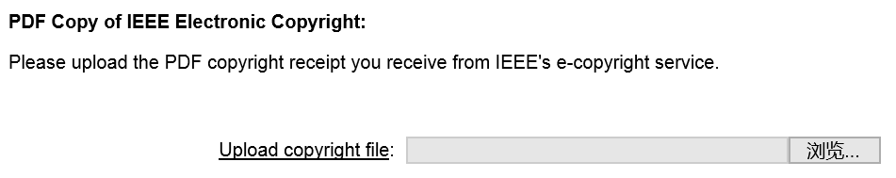
Step8: (a)Before upload your final submission here, please first log in IEEE PDF eXpress: https://www.pdf-express.org/ and follow their instructions to check your final PDF format meets IEEE Xplore requirements;
(b)Once you receive the congratulations email, save it in a text file named as”email.txt”;
(c)Then you can download your already checked PDF by click the paper title from IEEE PDF eXpress.
Step9: Upload your PDF obtained in Step8 (c).
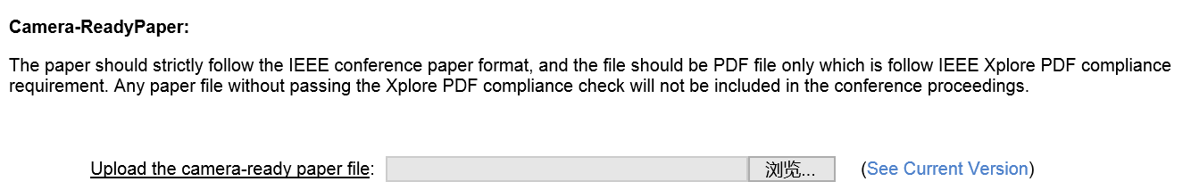
Step10: Upload the PDF Express Compliance Email obtained in Step8 (b)
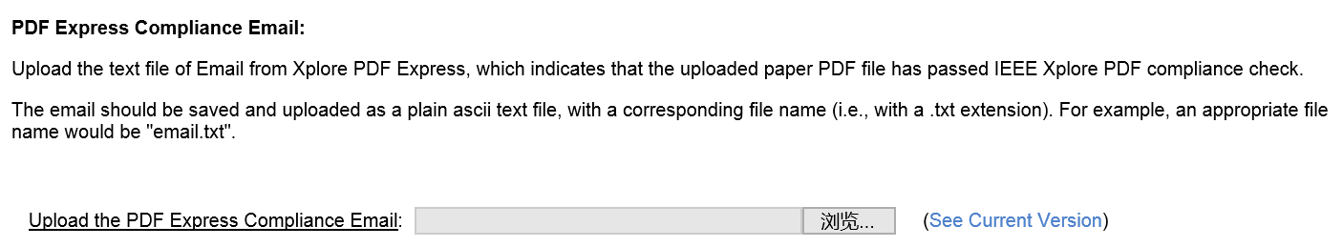
Step11: Upload the source file(s) which used to make your final PDF.
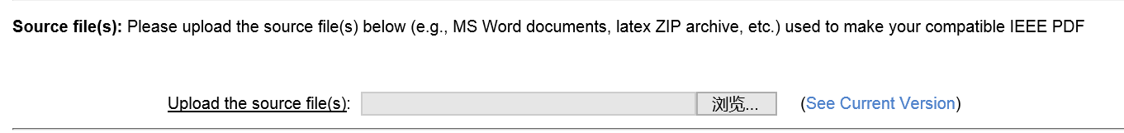
Step12: Upload your One-Page CyberDigest.ppt here.
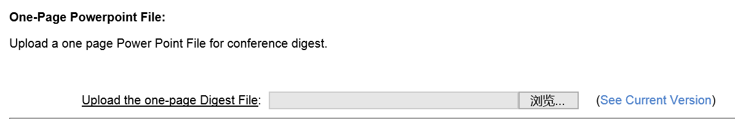
Step13: Click the option “Save” to finish the final submission.

IEEE Cyber 2015

